Building SPAs with

# Outline

* Introduction
* What is AngularJS?
* What are SPAs?
* 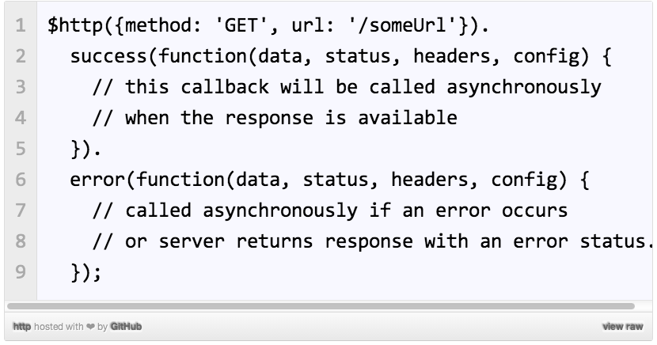MVC in AngularJS
* Modules
* $scope
* Controllers
* Directives
* Data binding
* Expressions
* Filters
* Services
* $http
* Promises
* Conclusion

# Abstract

The world of web applications has evolved dramatically since its beginning with new platforms, programming languages, and frameworks utilized by user programmers. Consequently, as new technologies such as AJAX arose within the developer community, web sites became more interactive. However, because the Web’s foundational components (HTML, JavaScript and CSS) were not best suited for more interactive web applications, new libraries tried to extend and improve the client-side web apps, but they were still missing the point. Nevertheless, a new solution to the problem of web interactivity is now available. Google has built a robust, test-driven, MVC-based framework called AngularJS designed to make the best out of the client-side, while giving the option for developers to work with already existing projects (server-side oriented) and keeping the compatibility necessary for them to run on legacy browsers. The architecture and design is a synthetic work of pragmatic and well-tested (theoretically and commercially) software design and principles. The purpose of this paper is to provide the reader a broad picture of what AngularJS is, what it is built for, and what are some of its major and best features.

References

[1] Google. (2012) AngularJS. [Online]. <http://docs.angularjs.org/guide/introduction>

[2] Microsoft. (2013) AngularJS. [Online].

<http://msdn.microsoft.com/en-us/magazine/dn463786.aspx>

[3] Mikito Takada. (2012, January) Modern web applications: an overview. [Online]. <http://singlepageappbook.com/goal.html>

[4] Google. (2012) AngularJS. [Online]. <http://docs.angularjs.org/tutorial/step_02>

[5] Google. (2012, August) Developer Guide, Expression. [Online]. <http://docs.angularjs.org/guide/expression>

[6] Ari Lerner, Ng-Book - the Complete Book On Angularjs. London: Fullstack io, 2013.

[7] Brad Green and Shyam Seshadri, AngularJS. Sebastopol, California, United States of America: O’Reilly Media, Inc., 2013.